Centre for Immunity, Infection & Evolution

School of Biological Sciences

Ashworth Laboratories

University of Edinburgh

Edinburgh

EH9 3FL

28 August 2020

Dear Editors of *Philosophical Transactions of the Royal Society B*,

We are pleased to submit an original research manuscript entitled “Optimising time-limited non-pharmaceutic interventions for COVID-19 outbreak control” for consideration of publication in the *Philosophical Transactions of the Royal Society B*,.

Severe non-pharmaceutical interventions (NPIs) such as stay-at-home orders and closure of non-essential business sectors have been used throughout the ongoing COVID-19 pandemic. However, these interventions carry great economic, physical and mental health costs and have proven to be controversial. Preliminary research has highlighted the potential for optimising the duration, trigger and strength of NPIs to mitigate the epidemiological and human health effects of future outbreaks.

Building on work conducted for the SPI-M advisory group during the initial stages of the UK COVID-19 outbreak, this manuscript explores the feasibility of optimising severe, time-limited NPIs using a mathematical model. A range of single/multi-duration NPI strategies were considered, representing different COVID-19 control strategies, to illustrate the concept of intervention optimisation.

For each considered NPI strategy, we identified specific values for the intervention duration, trigger point and magnitude that could minimise important epidemiological outcome measures. However, we find that there is very little room for error with these optimal interventions, with large increases in the epidemic peak and overall number of cases when mistimed or mis-implemented by even a small margin. As a more robust alternative, we also explore the concept of suboptimal interventions. While not as effective as intervention optimisation, these suboptimal interventions are more risk averse, less prone to implementation error and much easier to implement by policy makers.

This study presents the concept of NPI optimisation as a potentially powerful tool for policy makers. However, as evidenced by the COVID-19 pandemic, the initial epidemiological situation of an outbreak is often highly uncertain, making the introduction of these optimal interventions extremely difficult. In this context, suboptimal interventions that are less prone to implementation error are of greater benefit to policy makers. We note that the results must be contextualised with the work tirelessly undertaken by the wider epidemiological and modelling community. Nonetheless, we consider the findings of this manuscript to be of substantial public health interest, especially at a time where severe NPIs have been reinstituted globally to combat resurgent COVID-19 outbreaks.

Thank you for your consideration of this manuscript.

Yours sincerely,

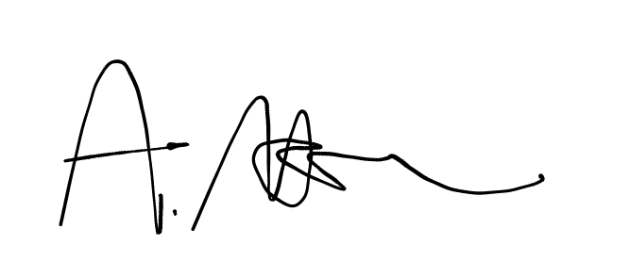

Alexander Morgan

And on behalf of all co-authors.